**Linux Lab 1**

**Introduction to Operating Systems**

An Operating System (OS) is a crucial software that acts as an intermediary between computer hardware and the user. It manages hardware resources and provides essential services for the execution of various applications. Here’s a brief overview:

Types of Operating Systems

• Batch Operating Systems: Execute jobs in batches without user interaction.

• Time-Sharing Operating Systems: Allow multiple users to interact with the system simultaneously.

• Distributed Operating Systems: Manage a group of independent computers and make them appear as a single system.

• Real-Time Operating Systems (RTOS): Designed for systems that require real-time processing.

• Embedded Operating Systems: Specialized OS designed for embedded systems with limited resources.

Examples of Operating Systems

• Windows

• Linux

• macOS

• Android

• iOS

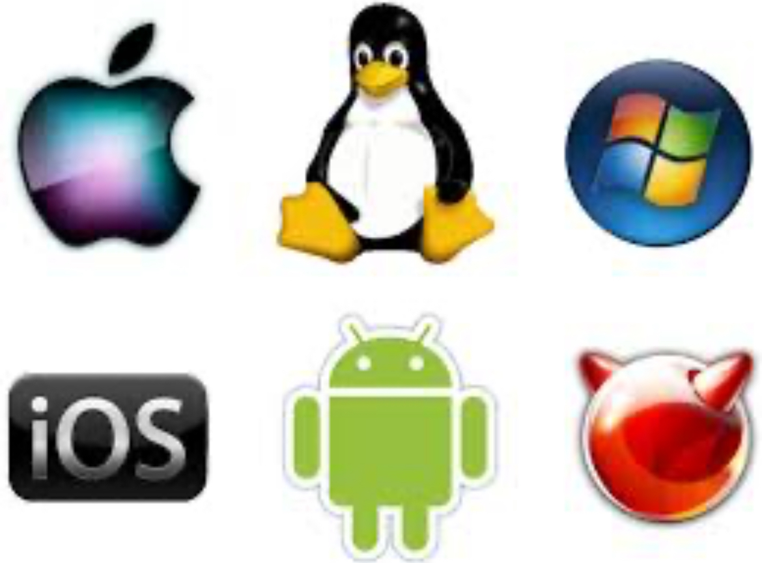

**Services of Operating Systems**

Operating Systems provide several essential services:

1. Process Management: Manages the execution of processes, including scheduling, creation, and termination.

2.Memory Management: Allocates and deallocates memory space for processes, ensuring efficient memory usage.

3.File System Management: Handles the creation, deletion, reading, and writing of files and directories.

4.Device Management: Manages hardware devices, facilitating communication between the OS and peripheral devices.

5.Security and Access Control: Protects system resources through user authentication and access permissions.

6.User Interface: Provides an interface (CLI or GUI) for users to interact with the system.

7.Error Detection and Handling: Detects errors in hardware and software, ensuring system stability.

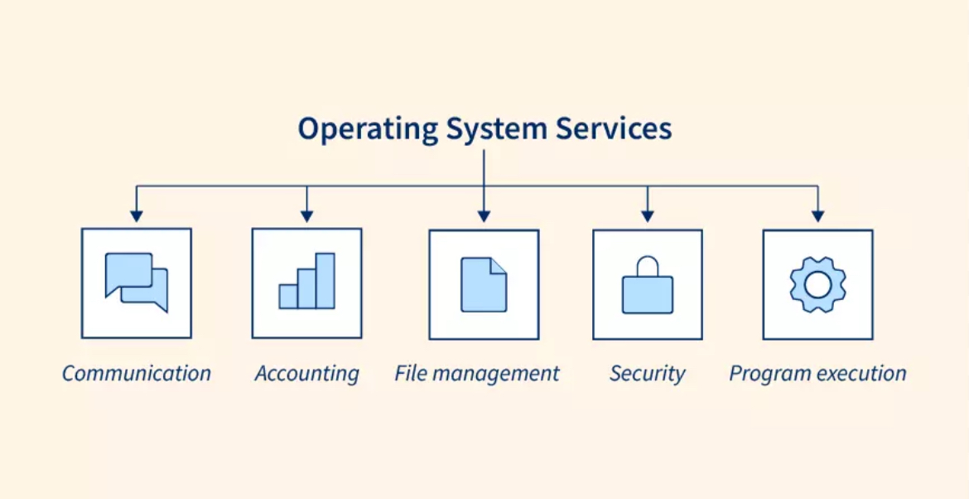

**Need for Operating Systems**

Operating Systems are essential because they manage hardware resources, provide a user interface, enable application execution, and ensure system security and stability, making it possible for users and software to interact with the computer efficiently.

**What is Linux?**



Linux is an open-source operating system based on the Unix architecture. It is widely used in servers, desktops, and embedded systems due to its stability, security, and flexibility. Linux is known for being highly customizable and free to use and modify, with popular distributions like Ubuntu, Fedora, and CentOS.

**Need for Linux**

Linux is needed because it offers a stable, secure, and flexible operating system that can be customized for various purposes. Its open-source nature allows for transparency and community-driven development, making it ideal for servers, developers, and users who require a reliable OS without licensing costs. Additionally, Linux supports a wide range of hardware and is known for its efficiency in resource-constrained environments.

**Services of Linux**

Linux provides several key services:

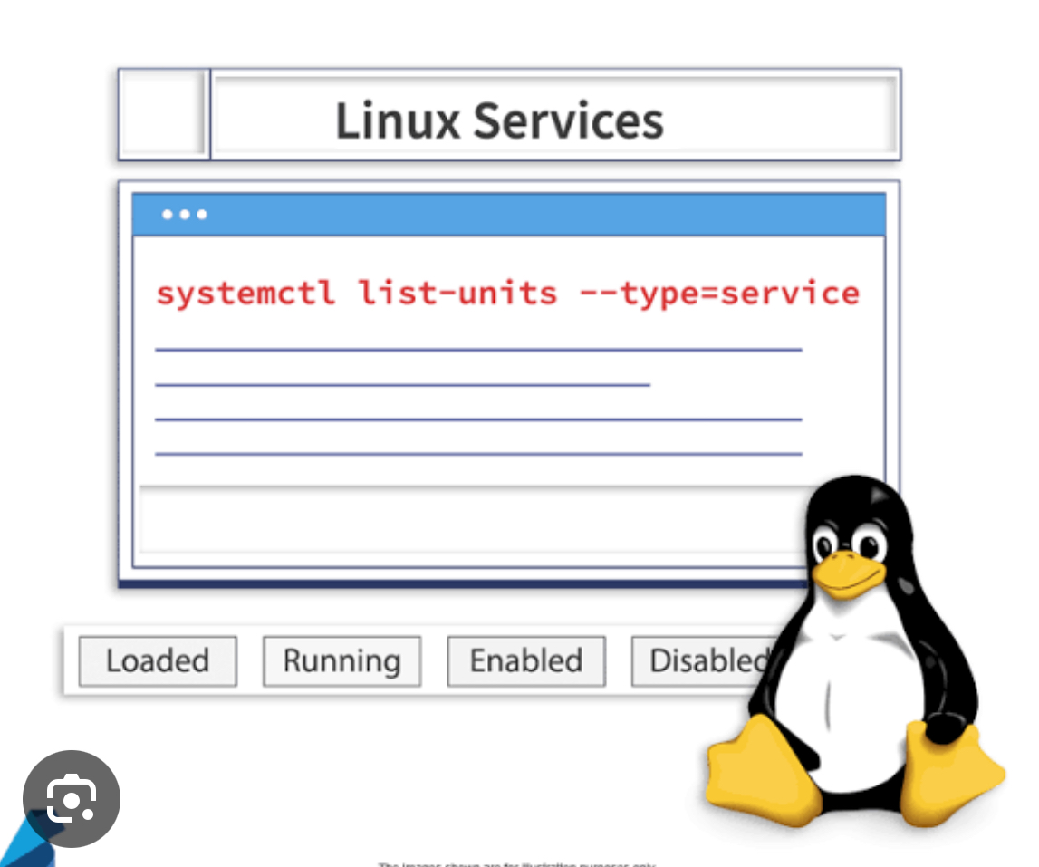

1. Process Management: Efficiently handles process creation, scheduling, and termination, supporting multitasking and concurrency.

2. Memory Management:Manages memory allocation, including virtual memory, ensuring efficient use of system resources.

3. File System Management:Supports various file systems (e.g., ext4, NTFS) for file storage, retrieval, and manipulation.

4. Device Management: Provides drivers and interfaces for hardware devices, facilitating communication between the OS and peripherals.

5. Security Management:Offers robust security features like user authentication, access control, and encryption.

6. Networking Services: Facilitates network connectivity and communication through various protocols, enabling server and client interactions.

7. User Interface:Provides both command-line interfaces (CLI) and graphical user interfaces (GUI) for user interaction.

8. Package Management: Manages software installation, updates, and removal through package managers like APT or YUM.

**History of Linux**

Linux was created by Linus Torvalds in 1991 as a personal project to develop a free operating system kernel. It has since grown into a robust platform supported by a vast community. Key milestones include:

- 1991: Initial release of the Linux kernel.

- 1992: Linux became a fully functional operating system.

- 1996: The first commercial distributions were released, paving the way for widespread adoption.

**Linux Distributions**

Linux distributions (distros) are different versions of the Linux operating system, each tailored for specific needs. They combine the Linux kernel with a package management system, software, and utilities. Here are a few popular distributions:

1. Ubuntu:User-friendly, popular for desktops and beginners, with strong community support.

2. Fedora:Cutting-edge features, backed by Red Hat, often used by developers.

3. Debian: Known for stability and extensive software repositories, often used on servers.

4. CentOS:A free, community-supported version of Red Hat Enterprise Linux, popular in enterprise environments.

5. Arch Linux:Lightweight and highly customizable, aimed at advanced users.

6. Mint:Based on Ubuntu, it's designed to be easy for newcomers, with a familiar interface.